**Delete Generated content files of Analysis report Scheduling.**

Note: You need Postman API extension in chrome to find the APIs for all actions

1. Login to pentaho user console.
2. Go to the folder where you stored generated content file.
3. Inspect ->Networks
4. Delete the file.
5. In networks part you can see the flow of file deletion.
6. Right click -> Copy -> Copy as cURL
7. Go to postman extension -> Import -> Paste raw text and press import.
8. In the JSON body you will get the Id of the file to be deleted and the folder filed will be set to false.

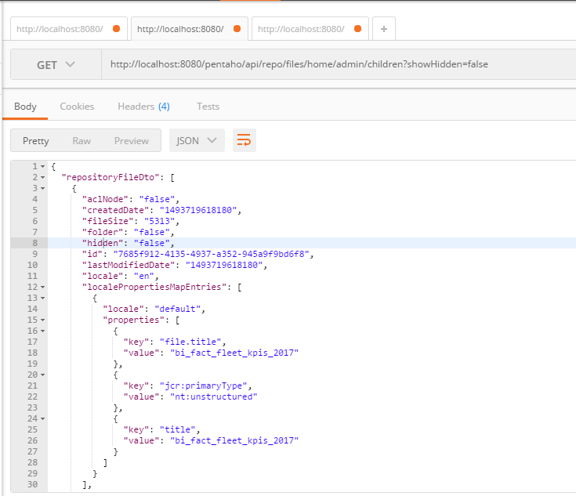

Sample JSON.

In the ETL using Restclient, give the API to fetch the JSON object.

Ex: <http://localhost:8080/pentaho/api/repo/files/home/admin/children?showHidden=false>

Above url will look for all the files inside folder /home/admin.

Get the id and folder from ‘repositoryFileDto’ Array.

In Restclient component, set body field to ID and the delete URL.

Ex: <http://localhost:8080/pentaho/api/repo/files/delete>